Sequence Diagram:
Admin Login Sequence Diagram:

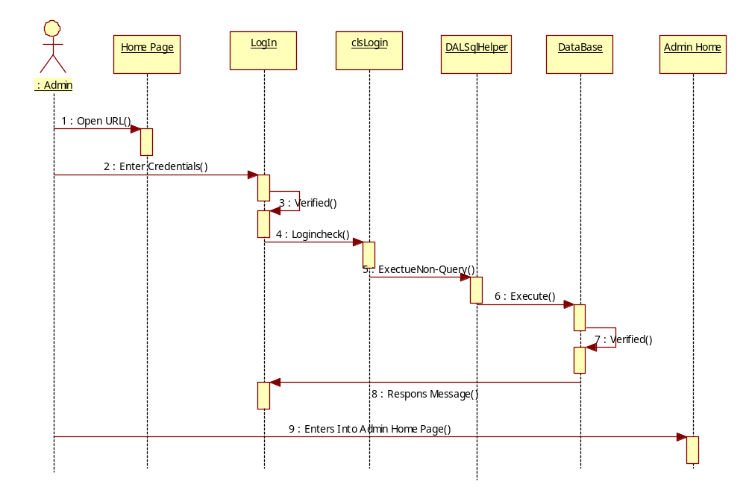
: Admin
LogIn
Admin Home
Add State
clsState
Dal SqlHelper
Database
1 : Enter Credentials()
2 : Verified()
3 : Enters Into Admin Home Page()
4 : Enters State Details()
5 : Add State()
6 : Execute NonQuery()
7 : Execute()
8 : Response Message()
Add District Details:

: Admin
LogIn
Admin Home
Add District
clsState
Dal SqlHelper
Database
1 : Enter Credentials()
2 : Verified()
3 : Enters Into Admin Home Page()
4 : Enters District Details()
5 : Add District()
6 : Execute NonQuery()
7 : Execute()
8 : Response Message()

Add City Sequence Diagram:
: Admin
LogIn
Admin Home
Add City
clsState
Dal SqlHelper
Database
1 : Enter Credentials()
2 : Verified()
3 : Enters Into Admin Home Page()
4 : Enters City Details()
5 : Add City()
6 : Execute NonQuery()
7 : Execute()
8 : Response Message()

Add Distributor Sequence Diagram:
: Admin
LogIn
Admin Home
Add Distributor
clsUser
Dal SqlHelper
Database
1 : Enter Credentials()
2 : Verified()
3 : Enters Into Admin Home Page()
4 : Enters Distributor Details()
5 : Add User()
6 : Execute NonQuery()
7 : Execute()
8 : Response Message()
Add Gas Cylinders Sequence Diagram:
: Admin
LogIn
Admin Home
Add Cylinders
clsAdmin
Dal SqlHelper
Database
1 : Enter Credentials()
2 : Verified()
3 : Enters Into Admin Home Page()
4 : Enters Cylinders Details()
5 : Add Cylinders()
6 : Execute NonQuery()
7 : Execute()
8 : Response Message()

Add View Reports Sequence Diagram:
: Admin
LogIn
Admin Home
View Reports
clsAdmin
Dal SqlHelper
Database
1 : Enter Credentials()
2 : Verified()
3 : Enters Into Admin Home Page()
4 : Select Report()
5 : ShowDitributor()
6 : ExecuteDataset()
7 : Execute()
8 : View Reports()

Distributor View User Request :
LogIn
Home
View New connection
clsUser
Dal SqlHelper
Database
: Distributor
1 : Enter Login Details()
2 : Verified()
3 : Get Home Page()
4 : Select User Request Details()
5 : ShowUserConnection()
6 : ExecuteDataset()
7 : Execute()
8 : Verified()
9 : View Requests()

LogIn
Home
View connection transfer request

clsUser
Dal SqlHelper
Database
: Distributor
1 : Enter Login Details()
2 : Verified()
3 : Get Home Page()
4 : Select Transfer Request
5 : ShowTrasnfer()
6 : ExecuteDataset()
7 : Execute()
8 : Verified()
9 : View Requests()

Consumer Sequence Diagram:

: Consumer
LogIn
Consumer
Home
clsUser
Dal SqlHelper
Database
1 : Enter Credentials()
2 : Verified()
3 : Enters Into Consumer Home Page()
4 : Enters Gas Booking Details()
5 : AddGasBooking()
6 : Execute NonQuery()
7 : Execute()
8 : Response Message()
Booking Request

